**Chapter 5: EXPLORING GRAPHS**

**Topic – 1: Summary**

* Introduction using graphs
* **Traversing tress –** Preconditioning
* **Depth first search –** Undirected graph
* **Depth first search –** Directed graph
* Topological sorting
* Breadth first search
* Backtracking
* General template
* Knapsack problem using backtracking
* Eight queens problem

**Topic – 2: Introduction Using Graphs**

**Representation**

**G = (V, E)**

* **Graphs** can be represented in form of ***adjacency list*** & ***adjacency matrix***.
* **Adjacency matrix:** Tells which nodes are connected in form of **0s** or **1s**.

**Adjacency List Representation (ALR)**

* We make **linked lists** from **each** possible node.

**ALR Example**

**Given:**

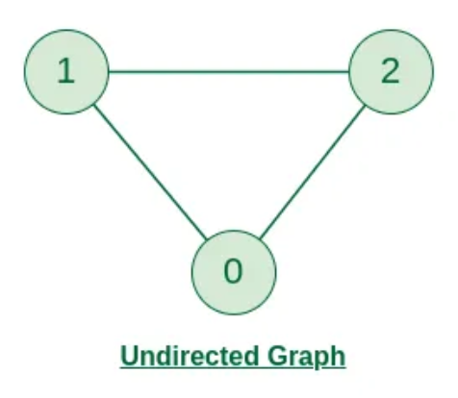

**ALR:**

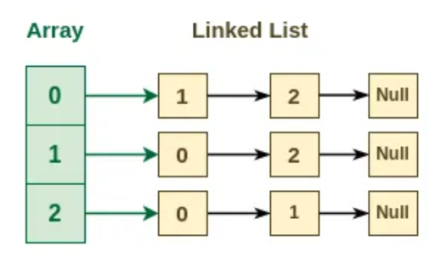

**Topic – 3: Traversing Trees**

**Traversing Methods**

* **Preorder:** Root 🡪 Left 🡪 Right
* **Inorder:** Left 🡪 Root 🡪 Right
* **Postorder:** Left 🡪 Right 🡪 Root

**Preconditioning**

* **Auxiliary** (intermediate) **results** can be used to sometimes **speed up** the solution calculation.
* **Preconditioning:** This whole process of calculating auxiliary result for future use.

**Let 'a' be the time it takes to solve one instance of a problem without auxiliary info.**

**Let 'b' be the time it takes to solve one instance of a problem with auxiliary info.**

**Let 'p' be the time it takes to calculate extra information.**

**Time taken to solve problems:**

**With auxiliary info = p + nb**

**Without auxiliary info = na**

* Using preconditioning is helpful only when **n > p/(a-b)**.
* This is again a kind of **dynamic programming** algorithm.

**Preconditioning Example**

* Finding if a **node** **A** is **parent node** of another **node B** or **not** will take us **O(n)**.
* But if we solve another problem where we traverse from **root node R** to **node B**, we can note the nodes coming between them, which includes **A**.
* This will take us **O(n)** when doing so.
* So, if we require to solve the first problem, we can find it in **O(1)** time.
* We can do it in two ways, using **preorder** or **postorder**.
* We number the **root R** in order first using **preorder** & at last using **postorder**.

**Topic – 4: Breadth-First Search (BFS)**

**Introduction**

* In **BFS**, we explore graphs in form of **trees**.
* We **pick up** a node & treat it as **root node R**.
* Then we proceed to explore its children.
* We start from the **nearest nodes** & then proceed toward nodes **further** away.

**Example**

* See the way of traversal in diagram below.

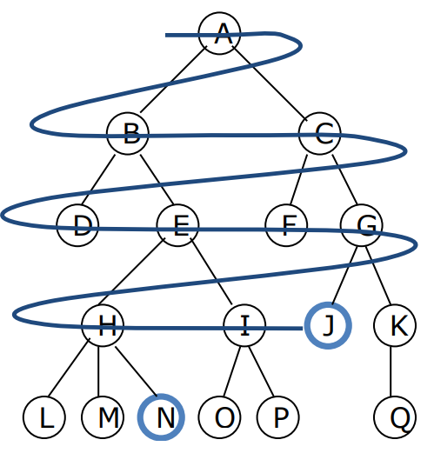

**Colour Guided Traversal**

* We can represent nodes in colour **white**, **grey** & **black**.
* **White –** Unexplored nodes
* **Grey –** Partially explored nodes
* **Black –** Fully explored nodes

**Colour Traversal Queue**

* We visit each node **one-by-one**, **children** of each node at a time.
* We enqueue **grey nodes** to a queue & dequeue **black** ones.
* After all is done, we dequeue them **one-by-one**.
* We initially draw the graph as shown below.

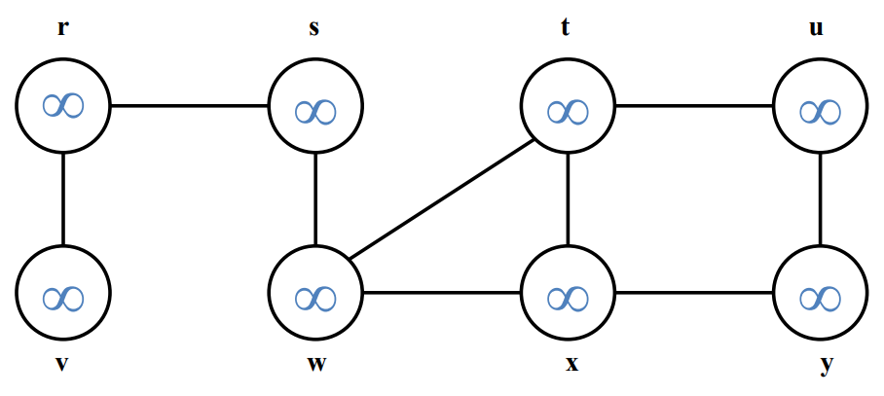

**Note!**

**🡪 Mind directions if it’s a directional graph.**

**Topic – 5: Depth First Traversal (DFS)**

**Introduction**

* As the name says, our way of traversal will be to get as **deep** in the tree (from graph) as possible.
* When we sense the **end of the tree**, we keep **returning** until an **unvisited path** is found.
* Finding an unvisited path this way is known as ***backtracking***.

**Example**

* It is traversed in the way shown in example below.

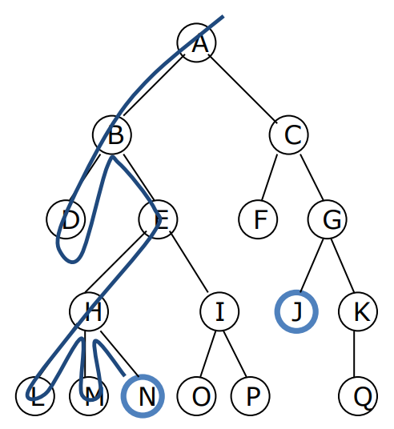

**DFS Stack**

* By traversing through a tree using **DFS**, we keep a **stack** with us.
* This **stack** contains the nodes connected to **current path**.
* These elements are too **popped** one-by-one.

**Colouring Method**

* **DFS** uses the same colouring method as **BFS**.
* The colouring is done **step-by-step** as shown in example below.

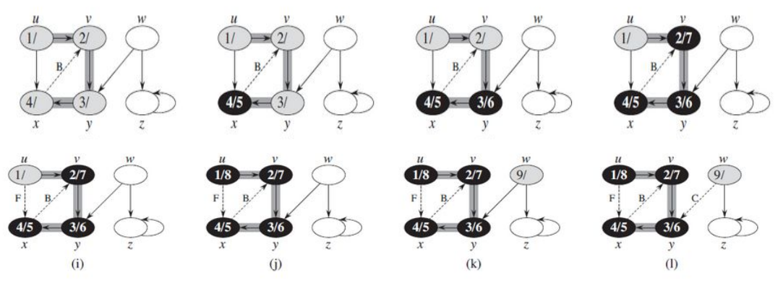

**Directed Acyclic Graph**

* **DAG** is a form of graph which **doesn’t** form any cycle.

**Topological Sorting**

* We construct or modify a graph in such a way that certain nodes are given **higher priority** than others.
* We use **DAG** to construct this type of graph.
* The directed graph must be set up this way so that say an **item A** must finish **before** **item B**.
* And there can be **multiple ways** to arrange the graph for same setting.

**Topological Sorting Example**

**Diagram:**

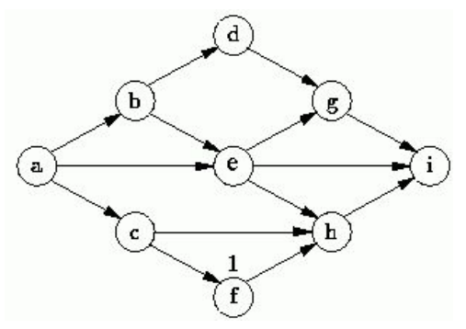

**Some possible represntations:**

**s1 = {a, b, c, d, e, f, g, h, i}**

**s2 = {a, c, b, f, e, d, h, g, i}**

**s3 = {a, b, d, c, e, g, f, h, i}**

**s4 = {a, c, f, b, e, h, d, g, i}**

**Topological Sorting & DFS**

* We try to make the graph as **linear** as possible, giving priority to **one node at a time**.
* But it is **not** very much necessary.
* We can do so by reverse ordering the **DFS** of the graph.

**Example**

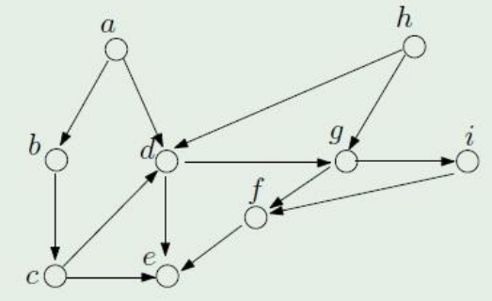

**Possible topological orders:**

**T0 = a, b, c, h, d, g, i, f, e**

**T1 = h, a, b, c, d, g, i, f, e**

**Backtracking**

* We come to know about some of the **possible choices** & choose one.
* Then we come to know about various other **possible choices** after that choice.

**Knapsack Using Backtracking**

|  |  |  |  |  |
| --- | --- | --- | --- | --- |
| **Weight** | **2** | **3** | **4** | **5** |
| **Profit** | **3** | **5** | **6** | **10** |
| **Capacity** | **8** | | | |

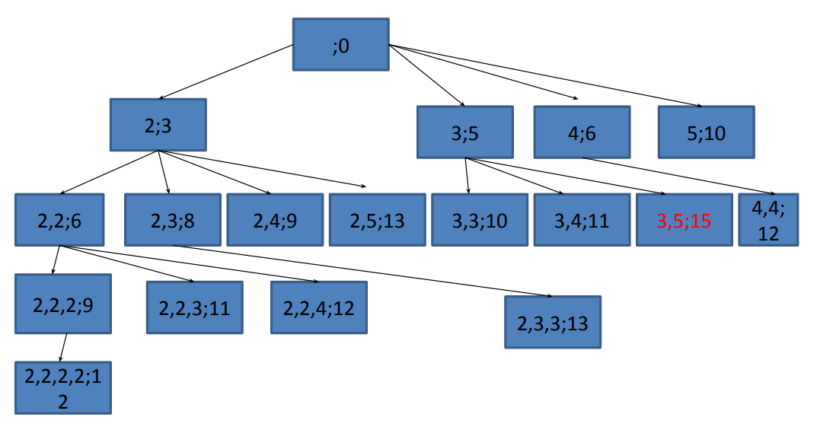

* Tree above shows nodes in format (**w1,w2,…,wn ; profit**).
* **Memoization:** Constructing/storing solutions while **also** solving the problem.

**Note!**

**🡪 Profit mustn’t cross the capacity.**

**N-Queen Problem**

* This problem discusses how to arrange **N queens** on an **N*N** chess board.
* Suppose this **3-queen** **problem** given below.

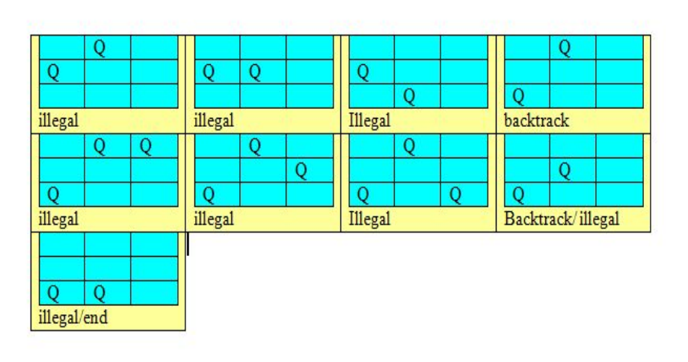

* As we saw some of the steps in solving a **3-queen problem**, we start with **two queens**.
* Then we check at what position they **can’t** attack each other.
* And then we add another, then check with it.
* In case the last added queen fits **no** such place, we **backtrack** & place the **last queen** in another position invulnerable to attack.
* If then that fails, we **backtrack** to even its **previous queen** etc.

**State Space Tree**

* ***State space tree*** is a representation of various **possibilities** of a problem.
* Let’s take a look at how it will look for a **4-queen problem**.

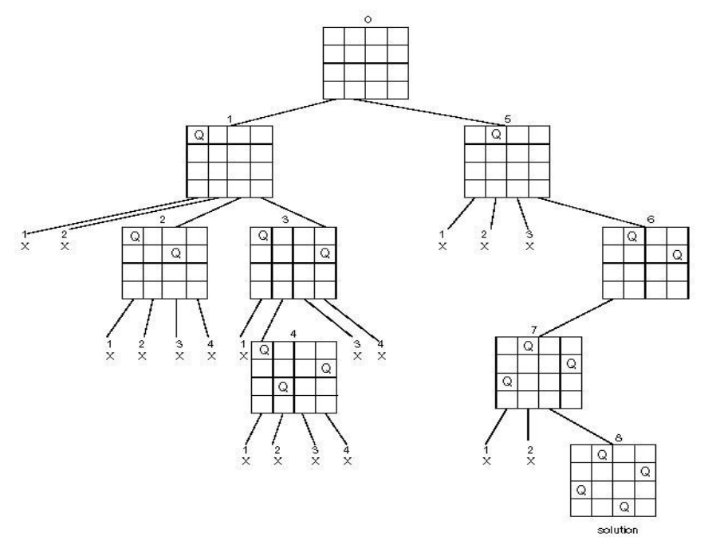

**Topic – 7: Other Types Of Graphs**

**Articulation Graph**

* A graph which has some **nodes/vertices** (***articulation points***) which are crucial in maintaining **connectivity** & **structure** of the graph.
* Removing **articulation points** will result in total **demolition** in graph’s structure or connectivity.
* It is applicable on **undirected graphs** only.

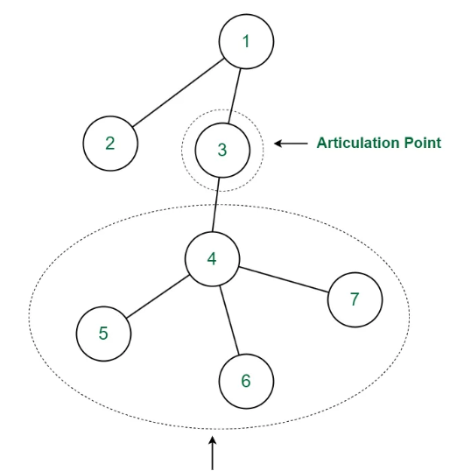

**Dense Graph**

* A graph in which the total number of **edges** are **close** to the **maximum** number of edges possible.
* But as anyone will notice, this definition is very **informal** as there is **no fixed value** for ***"close to maximum"***.
* More **formal** definition will be a graph whose number of edges **E** grows with rate of **O(n2)** when vertices are added.

**Sparsh Graph**

* Complete **opposite** of **dense graphs**.
* In these graphs, the number of edges are very **less** than the **maximum** possible number of edges.
* More formal definition will be a graph whose number of edges **E** grows with rate of **O(n)** when vertices are added.